ДАНА КЕНДЫБАЕВА LAB5

**create database** lab5;  
  
**create table** customers(  
 **customer_id int**,  
 **cust_name varchar**(100),  
 **city varchar**(100),  
 **grade int**,  
 **salesman_id int**);  
  
**create table** orders(  
 **ord_no int**,  
 **purch_amt float**,  
 **ord_date date**,  
 **customer_id int**,  
 **salesman_id int**);  
  
**insert into** customers **values** (3002, **'Nick Rimando'**, **'New York'**, 100, 5001),  
 (3005, **'Graham Zusi'**, **'California'**, 200, 5002),  
 (3001, **'Brad Guzan'**, **'London'**, **null**, 5005),  
 (3004, **'Fabian Johns'**, **'Paris'**, 300, 5006),  
 (3007, **'Brad Davis'**, **'New York'**, 200, 5001),  
 (3009, **'Geoff Camero'**, **'Berlin'**, 100, 5002),  
 (3008, **'Julian Green'**, **'London'**, 300, 5002);  
  
**insert into** orders **values** (70001, 150.5, **'2012-10-05'**, 3005, 5002),  
 (70009, 270.65, **'2012-09-10'**, 3001, 5005),  
 (70002, 65.26, **'2012-10-05'**, 3002, 5001),  
 (70004, 110.5, **'2012-08-17'**, 3009, 5003),  
 (70007, 948.5, **'2012-09-10'**, 3005, 5002),  
 (70005, 2400.6, **'2012-07-27'**, 3007, 5001),  
 (70008, 5760, **'2012-09-10'**, 3002, 5001);  
*--3***select** *sum*(**purch_amt**) **from** orders;  
*--4***select** *avg*(**purch_amt**) **from** orders;  
*--5***select** *count*(*\**) **from** customers **where customer_id in** (**select customer_id from** orders);  
*--6***select** *min*(**purch_amt**) **from** orders;  
*--7***select** *\** **from** customers **where cust_name like '%n'**;  
*--8***select** *\** **from** orders **where customer_id in** (**select customer_id from** customers **where city** = **'New York'**);  
*--9***select** *\** **from** customers **where customer_id in** (**select customer_id from** orders **where purch_amt** > 10);  
*--10***select** *sum*(**grade**) **from** customers;  
*--11***select** *\** **from** customers **where customer_id in** (**select customer_id from** orders);  
*--12***select** *max*(**grade**) **from** customers;

#3

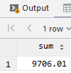

#4

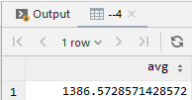

#5

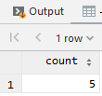

#6

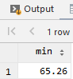

#7

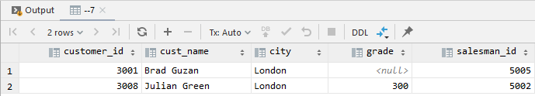

#8

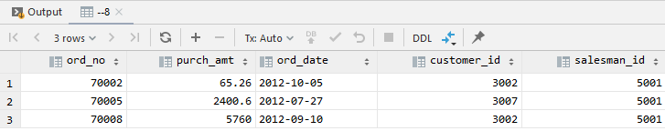

#9

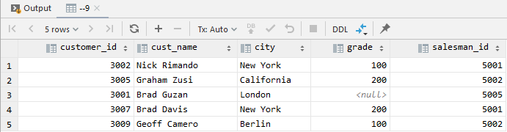

#10

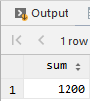

#11

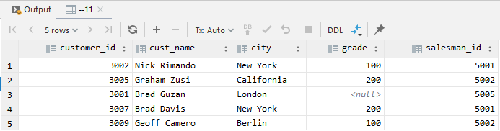

#12

